Relay using led_on_off
Arduino code:
#include <OneButton.h>
#include <Wire.h>
#include <LiquidCrystal_I2C.h>
// I2C LCD address
LiquidCrystal_I2C lcd(0x27, 16, 2);
// Button pin
OneButton button(A0, true); // INPUT_PULLUP
// Relay pins
#define L1 2
#define L2 3
#define L3 4
// Relay states
bool RLY1 = LOW;
bool RLY2 = LOW;
bool RLY3 = LOW;
void setup() {
pinMode(L1, OUTPUT);
pinMode(L2, OUTPUT);
pinMode(L3, OUTPUT);
digitalWrite(L1, RLY1);
digitalWrite(L2, RLY2);
digitalWrite(L3, RLY3);
// LCD init
lcd.init();
lcd.backlight();
lcd.setCursor(0, 0);
lcd.print("One Button Demo");
lcd.setCursor(0, 1);
lcd.print("Ready");
// Button events
button.attachClick(singleClick);
button.attachDoubleClick(doubleClick);
button.attachLongPressStart(longClick);
}
void loop() {
button.tick();
}
// -------- BUTTON FUNCTIONS --------
// Single click → Relay 1
void singleClick() {
RLY1 = !RLY1;
digitalWrite(L1, RLY1);
lcd.clear();
lcd.setCursor(0, 0);
lcd.print("Single Click");
lcd.setCursor(0, 1);
lcd.print("Relay1: ");
lcd.print(RLY1 ? "ON" : "OFF");
delay(500);
}
// Double click → Relay 2
void doubleClick() {
RLY2 = !RLY2;
digitalWrite(L2, RLY2);
lcd.clear();
lcd.setCursor(0, 0);
lcd.print("Double Click");
lcd.setCursor(0, 1);
lcd.print("Relay2: ");
lcd.print(RLY2 ? "ON" : "OFF");
delay(500);
}
// Long press → Relay 3
void longClick() {
RLY3 = !RLY3;
digitalWrite(L3, RLY3);
lcd.clear();
lcd.setCursor(0, 0);
lcd.print("Long Press");
lcd.setCursor(0, 1);
lcd.print("Relay3: ");
lcd.print(RLY3 ? "ON" : "OFF");
delay(500);
}

Circuit diagram:

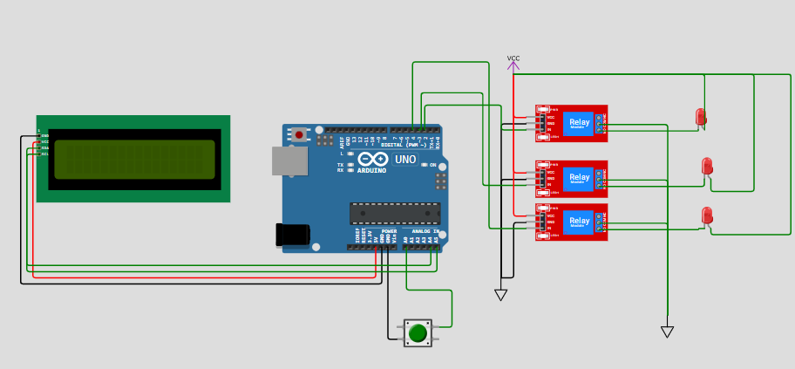

Output:

